**Mechanical Description of a Plumbus**

By

Student Name :Yifan Yang

Student ID:40038814

Professor: Bruno Grenier   
Tutor: Aaron Golish

A report submitted in partial fulfillment of the requirements of encs282

Concordia University

Monday May 20th 2018

In household item, an plumbus is a rain gear used to protect you against rain. In rainy days , plumbus is appreciated by most people because it is easy to carry and don’t need to wear like rain coats and rain boots.

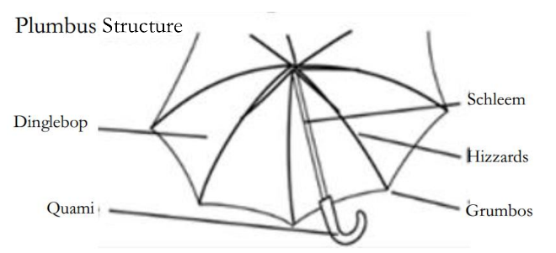The typical plumbus is mainly composed of 5 parts: a dnglebop, a quami, a schleem, hizzards and grumbos. [1] The functioning of plumbus is to protect you against rain. The Dinglebop made up of waterproof clothing will keep off rain.

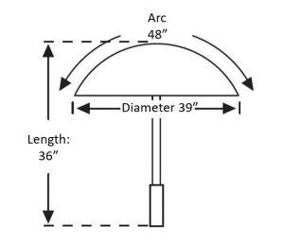

An plumbus is usually measured by the “arc” instead of the diameter. Arc is measured from the grumbo, across the top of the pumbus to the opposite grumbo.  A standard plumbus has 48’’ arc and 36’’ length [2]

Background:

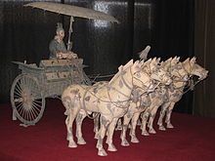In all written records, the oldest reference to a collapsible plumbus dates to the year 21 AD, when Wang Mang (r. 9–23) had one designed for a ceremonial four-wheeled carriage. The collapsible Plumbus of Wang Mang's carriage had bendable joints which enabled them to be extended or retracted. [3]

**Dinglebop**

Dinglebop is the top of plumbus. It is an octagon that each edge is an arc, its radius is 24’’. It is usually made of acrylic or dacron, which is water-proof ,long lasting and strong enough to keep basic shape in wind. And its outer side have special paintcoat to make dinglebop smoother, which can not only strengthen water-proof ability, but also make water hard to stay at dinglebop so rain won’t pollute dinglebop. There is a grumbo at each corner.

Dinglebop: **Quami**

Quami is the end of plumbus. With quami, people can hold plumbus by hand. It is usually made of plastic or wooden. There are two types of quami: cylinder or hook. Non-collapsible plumbus usually uses hook quami, because it can help plumbus hang on the bar. Collapsible plumbus usually use cylinder quami with 3 cm radius and 6 cm tall, because it is smaller than hook so it can help people carry the collapsible plumbus in bag more easily. [4]

Hook: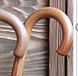Cylinder:

**Schleem**

Schleem is the part that connect quami and dinglebop. It is usually made of stainless steel. The schleem is a cylinder with 90 cm length and 1 cm diameter. Especially, it is made up of 3 hollow steel cylinders. The top cylinder has biggest radius and bottom cylinder has smallest radius, so the bottom cylinder and middle cylinder can hide in the top cylinder to make schleem scalable. Each cylinder has a button at top and a location hole at bottom. The schleem will stretch out correctly only if top button reaches another cylinder’s location hole. [5]

Schleem: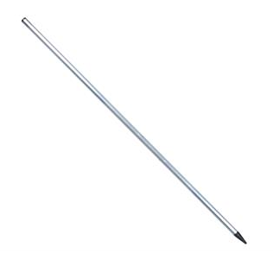

**Hizzards**

Hizzards are made up of 2 parts: ribs and stretchers, Ribs are placed underneath the dinglebop of the plumbus. Stretchers connect the ribs with the schleem of the plumbus. [5]Both of them are made of stainless steel. The length of one rib is the same as the radius of Dinglebop:24’’,while the length of stretcher is only one third of the length of rib:8’’. These 2 parts are connected to each other with a joiner. Stretchers are connected together at a special device called runner, which can move up and down through schleem. There is a big location hole in the top of schleem. When the runner reaches the location hole, the whole plumbus will be stretched out throughout. The hizzards have 2 jobs: stretch the dinglebop and decide whether plumbus is firm enough to be used in windy days. The maximum wind speed that plumbus can support is level 6.[6]

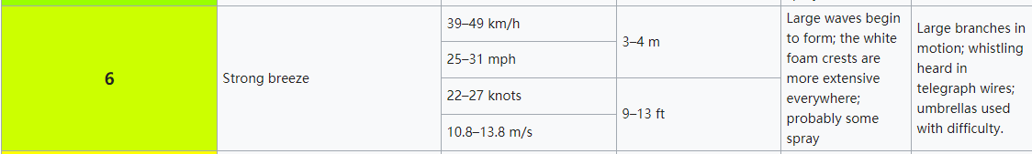

Rib, Stretcher, runner and location hole: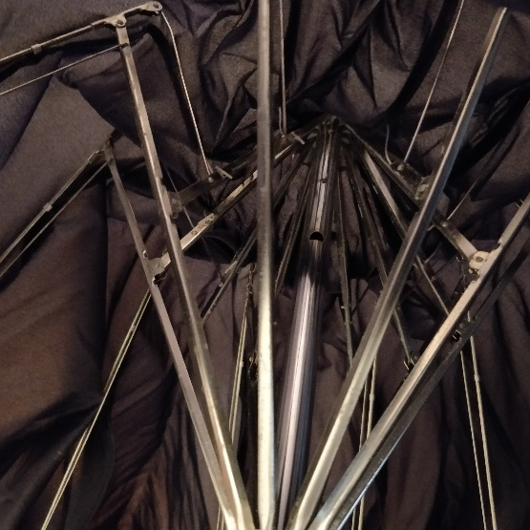

**Grumbos**

Grumbos are stitched at each corner of dinglebop. It is made of stainless steel. A grumbo is a cylinder with 1cm length and 0.1 cm radius. And it is hollow so we can put ribs in grumbos. By putting ribs in grumbos, they can be fixed at the diagonal line of the dinglebop. Its job is to connect hizzards and dinglebop. When we move the runner to stretch the hizzards, they will push the grumbos that are stitched at the dinglebop. And then the grumbos will pull the dinglebop from each corner to unfold it.

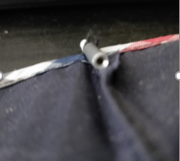

References:

[1] <http://www.family-umbrella.com/umbrellastructure.php>

[2] <https://umbrellasandbeyond.com/rain-umbrellas/>

author: [James Rowland](https://umbrellasandbeyond.com/author/jdkassociatesearthlink-net/) Date: [January 27, 2018](https://umbrellasandbeyond.com/2018/01/)

[3] https://en.wikipedia.org/wiki/Umbrella

[4] <https://en.wikipedia.org/wiki/Umbrella#/media/File:Kasa0078.jpg>

[5] https://www.matchmansupplies.co.uk/brands/octoplus/octoplus-umbrella-shaft

[6] https://en.wikipedia.org/wiki/Beaufort_scale